**WARMINSTER UNITED CHURCH**

**Dec 2014 to Feb 2015**

**Warminster United Church**

**George Street, Warminster BA12 8QA**

**Minister: Revd David Coppard**

**Tel: 01373858805**

**email:** [**dave.coppard@yahoo.co.uk**](mailto:dave.coppard@yahoo.co.uk)

**Bookings & room hire: 07506065235**

**Web site: www.unitedchurchwarminster.org.uk**

**Newsletter editor email: iantojo@virginmedia.com**

**SUNDAY SERVICES**

**10.30a.m.**

**DECEMBER:**

**7th: Rev. Mike Burrell**

**14th : Douglas Colbourne**

**3.30p.m Carol Service – see details elsewhere in Newsletter**

**21st: Rev. David Coppard – to include extracts from musical ‘Travelling Light’**

**28th: Rev. David Coppard – All age worship**

**JANUARY:**

**4TH: Local arrangements**

**11th: Rev. Mary Teed**

**18th : Rev. David Coppard COVENANT SERVICE**

**25th : Rev. Heather Morgan HOLY COMMUNION**

**FEBRUARY:**

**1st: Rev. Mary Teed**

**8th : Pat Clarke**

**15th: Rev. David Coppard**

**22nd : Local arrangements HOLY COMMUNION**

**There is also a weekly service on Wednesdays at 10.15 a.m.**

**~~~~~~~~~~~~~~~~~~~~~~~~~~~~~~~~~~~~**

**C:\Users\Joan and Evan\AppData\Local\Microsoft\Windows\Temporary Internet Files\Content.IE5\BMFHRC9K\MC900058355[1].wmfAfter the service**

**ON JANUARY 18TH**

**there will be**

**a BRING AND SHARE LUNCH**

**and a chance to discuss ideas about church development**

Dear Friends

Compiling these thoughts on a sunny and relatively warm day it hardly feels possible that we are in mid-November.

This time of year with its dark evenings allows for reflection and memory, it is also a time to hope and dream.  In this edition of the magazine you will see how we as a congregation are challenged to hope and dream about our rear rooms.  What is the best way forward, should we demolish and start again or seek to refurbish?  **Please, please, please put your views in the Suggestion Shoebox in the vestibule.  We have only one opportunity to get this right and your view matters!**

Hoping and dreaming are highly Biblical especially at this time of year.  For centuries people longed for the coming of the Christ.  Think of those words we often read at our Carol Service from Isaiah 9, “The people who walked in darkness have seen a great light.”  They were spoken around 800 years before the coming of Christ.  Yet the people of faith kept on dreaming and hoping.

T**he challenge for us in this current age is to have hopes and dreams that make sure the light of Christ continues to shine.**I’m always reminded at Christmas time of the a story of the famous Scottish novelist and poet Robert Louis Stevenson, author of Treasure Island, who had a difficult childhood due to ill health.

One night, his nurse found him out of bed with his nose pressed against the window. “Come here child”, she said, “you’ll catch your death of cold.”  
But he wouldn’t move from his position. Instead he sat, enthralled, watching a lamplighter slowly working his way through the black night, lighting each street light along the way.  Pointing to him, Robert said, “See, look there; there’s a man poking holes in the darkness.”

As we journey through this incredibly poignant and special time of year may we find ourselves absolutely enthralled by the God who, in Jesus Christ, continues to poke holes in the darkness of our world.

Shalom Rev David.

**ADVENT BIBLE STUDY**

An Advent Bible Study based, around the BBC **“The Nativity”**  using study notes prepared by The Bible Society, will be taking place.

This is an opportunity for everyone from all four of David’s churches and indeed further afield to share together as we make our Advent journey.

Each session will last for about an hour.

**Episode 1     Setting the scene.**

Thursday     27th  November-   3pm   Westbury URC

Friday          28th  November -  7pm    Steeple Ashton

**Episode 2     Gabriel visits Mary.**

Thursday     4th   December -   3pm   Westbury URC

Friday          5th    December -   7pm   Steeple Ashton

**Episode 3  The Journey to Bethlehem.**

Thursday     11th  December -   3pm   Westbury URC

Friday          12th   December -  7pm   Steeple Ashton

**Episode 4  The Incarnation.**

Thursday     18th  December -   3pm   Westbury URC

Friday          19th   December -   7pm   Steeple Ashton

**For further information contact Rev David 01380 858805**



**Light up a Life Service.**

**Warminster United Church**

**Thursday December 4th at 6pm**.

It is an opportunity to remember loved ones within a service of carols and readings.

Refreshments will be served following the service

Everyone is warmly invited to attend what we hope will become an annual event.



**AN ADVENT EVENING**

**Saturday 6th December**

**5 - 6.30p.m.**

**Programme includes**

**"TRAVELLING LIGHT"**

**A MUSICAL FOR CHRISTMAS**

**by Heather Morgan**

**Followed by a Tea and Carols**

**~~~~~~~~~~~~~~~~~~**

**C:\Users\Joan and Evan\AppData\Local\Microsoft\Windows\Temporary Internet Files\Content.IE5\BMFHRC9K\MC900435424[1].wmf CAROLS BY CANDLELIGHT**

**Sunday 14th December**

**3.30 p.m.**

**Hot drinks and mince pies after the service**

**~~~~~~~~~~~~~~~~~~~~~~~~~~**



**There will be a collection at Advent Evening and Carol service for Crisis at Christmas.**

**Being homeless at Christmas can be hard to bear. Cold, wet and hungry with nowhere to go. It can be a lonely desperate time – but a place at Crisis at Christmas can be the start of a whole new life . It could even help someone out of homelessness for good. Crisis at Christmas starts on 22 December and lasts 9 days. A place costs £21.62 and as well as a delicious hot dinner a donation could also provide a health check, dentist’s appointment, a haircut, help to deal with drink or drugs problems, advice on housing, support to find a job. Your donation will help Crisis offer as many people as possible a hot meal and other help**

**CHRISTMAS CELEBRATIONS IN THE MALL**

**13th December, 10.30 a.m.**

**one hour will be led, this year, by us, the United Church.**

**A small committee will meet to prepare the service and if you would like to join in, please come on Saturday 13th at 10.30. The Mall’s new owners are delighted to have a carol service, and have said they will put up some advertising on our behalf. The Baptist Church often helps out with mince pies, but we will need flasks of hot water for drinks. The Kings Tent will probably be there and maybe the Breakout youth will attend. Karen has contacted New Close Primary School Choir to see if they will sing with us. Printed service sheets will include times of Christmas Services for all the churches. See you there!**

~~~~~~~~~~~~~~~~~~~~~~~~~~~

**CHRISTMAS WEEK SERVICES**

**Sunday 21st**: Led by Rev David Coppard will include extracts from the musical ‘Travelling Light’

**Christmas Eve**: 10.15 a.m. : This Wednesday morning service will include Holy communion

**CHRISTMAS DAY**

We are invited to join with our friends

at the Baptist Church in North Row

C:\Users\Joan and Evan\AppData\Local\Microsoft\Windows\Temporary Internet Files\Content.IE5\BMFHRC9K\MC900241923[1].wmfat 10 a.m.

**PASTORAL REPORT**

I should like to thank all the church members who give their time so willingly as Pastoral Carers, looking after each one of us in the congregation. It is a mark of our care for each other that makes our church community so welcoming.

This year we have celebrated the lives of older members, remembering them in love, and have supported those amongst us who are or have been sick. We think of June Laird, Ruth and David, Daphne, John Hornby, John Hewitt, remembering Sue as she supports him constantly and Betty Fielding. We continue to remember those friends who can no longer attend the church service on Sunday but who keep us in their prayers , including Audrey and Howard, Ivy, Bernard; many not known to more recent members of the congregation who have joined us as our church family continues to evolve.

Our connections with the Army families appear tenuous, with few visits from the families who used to join us; however movements and a decrease in the number of soldiers may be the reason. If you have links with the military services, then please let me know if we can offer assistance or encourage members to join us.

It is a pleasure to welcome so many friends from Imber Court and trust that they will continue to join us, not only in services but in our other activities too.

Should you have any questions, then please do not hesitate to contact me; as you are aware we are all being more mindful of confidentiality so cannot always share details.

Marion Barton

**FRIENDSHIP CLUB**

The few of us who belong enjoy meeting regularly every month for tea, chat and playing ‘Rummikubs’ . If anyone else is interested we can also offer ‘Scrabble’ and various card games etc.

New members would be very welcome to join us on the 1st Tuesday of each month at 2.30 p.m. in the foyer.

Margaret Edwards

**PRAYER GROUP**

At the time of writing two of us meet regularly on the 2nd Friday of each month to pray for the charity coffee morning being held next day and for individuals, the church and our fellowship, and any other issues that we feel led to pray for.

Please join us if you can at 3.30 p.m. in the foyer.

Margaret Edwards

**C:\Users\Joan and Evan\AppData\Local\Microsoft\Windows\Temporary Internet Files\Content.IE5\2F0QHDEQ\MC900238703[1].wmfSEWING GROUP**

The sewing group continues to grow. Amazingly we have 24 members now and around 15 to 20 attend regularly. Around half the members belong to the church family. We have quite a few knitters, wonderful beading and one member who has so many craft ideas it puts the rest of us to shame! We have one or two quilters who have made quilts for a children’s hospice. It is a good group for some who just like to come for a chat and make new friends. Rev David comes to visit us sometimes and is a dab hand at washing up! He likes it even better if it is someone’s birthday and we have cake! We have a Christmas visit for tea and cake and Lakeside is a very good choice again this year

Pam Copeland

**C:\Users\Joan and Evan\AppData\Local\Microsoft\Windows\Temporary Internet Files\Content.IE5\2F0QHDEQ\MC900193998[1].wmf COOPER HOUSEGROUP**

The current membership is now only 6 or 7 and that is the usual attendance at each meeting. We usually meet on the third Monday of each month at one of the member’s homes. Our meeting time is 7.30p.m. This year we have been studying an Old Testament Overview entitled ‘Full of Promise’ and it has given us an opportunity to learn more of Israel and Judea’s response to God’s covenant promise given to Abraham. It traces the promise through from Genesis to Nehemiah. At the end of each study there are the usual standard questions but also implication questions for us in the present day. There are 8 studies but we have found that it is more beneficial to divide each study into two sessions so that we may consider the implication questions separately. Each session is lead by one member of the group. As our membership is no longer as many as in the past we would welcome any person who would like to join us. If anyone is interested please contact either Pam or Derrik Copeland.

**ACTION FOR CHILDREN**

Total amount collected from boxes last January, February and March was £525.03, this is slightly down on last year.

I have gained 2 people , but lost 5 for various reasons.

The Charity coffee morning in August raised £139.01

I will be wanting boxes for emptying in February 2015 please.

I have some spare boxes and would be pleased to hear from anyone who would like to have one to collect their loose change for this worthwhile charity.

Diana Bennie

**The Week of Prayer for Christian Unity**

**Dates and places have been provisionally decided as:-**

**Monday January 19th:  St John’s 12.30 with lunch**

**Tuesday January 20th:  Christ Church 12.30 with lunch**

**Wednesday January 21st:  Foundation Christian Fellowship 12.30 with lunch**

**Thursday January 22nd:  St Georges 12.30 with lunch**

**Friday January 23rd:  United Church 12.30 with lunch**

**Saturday January 24th  (Baptist or Minster) 12.30 with lunch**

**Sunday January 25th:  Sunday Worship (Baptist or Minster)**

**(Usually around 3pm)**

(Venues will be confirmed in the notices)

**IS THIS SOMETHING YOU COULD DO??**

Pam Copland has been responsible for **contacting the Minister or local** **preacher who is to take our Sunday service each week**. Having done this faultlessly for many years she now wishes to stop. Thank you Pam for all you have done. **A volunteer is needed to take over this job**. Now that most people have computers and preachers can be contacted by email it is less time consuming than in the past. It is an important job but not too onerous. If you feel you could take this on then please have a word with Pam and she would be happy to explain what is involved.

**OR THIS??**

**Ashwood , the new care home on the site of the old Beckford Centre in Gypsy Lane has invited our church to lead a short act of worship there once a month. Rev David Coppard would be pleased to hear from anyone who would like to join him in a small group to help lead this 20 minute service.**

**OR MAYBE THIS?**

The position of Health and Safety /Fire officer on the Property Committee is vacant. We should really have someone responsible for this! If you feel able to take this on then please speak to one of the Committee.

**PLANS , HOPES & DREAMS for our Church**

**On the next pages are suggestion that have been made about the possible development of the rear of the church building . Please read these thoughtfully . There is a suggestion box in the foyer for your ideas , comments and suggestions regarding this development**

**Thoughts from Pauline Howell**

**THE FUTURE OF OUR CHURCH**

**Function :** To encourage worship and fellowship in the community

**Form:** To make our building accessible to all and effective as a place to bring people together.

**Finances:** Currently we need another £200 a week to get us on an even keel. One way to achieve this would be 20 hours every week of additional letting. With additional letting comes additional responsibilities.

**Some of the things we need to address are:**

**Improved access for wheelchair and walking-frame users**

As we can do nothing with the short, sharp slope at David Wiltshire’s side ,

*I suggest more use is made of the Pine Shop side as this is virtually level.*

**Modern toilet facilities with improve drainage and water supply**

We cannot trace where the rear toilets drain out, and the toilet in the foyer is piped diagonally under the main church floor to the rear drain outside the back door.

*My suggestion would be to install a new drain in the ground on the Pine Shop side straight into the main sewer in the main road*

Currently no single stop-cock has been located inside the building. Water supply comes into the building in the cupboard in the foyer toilet and travels to the rear of the building

*My suggestion would be to install a new water supply in the ground on the Pine shop side. If modern toilets are installed as per the drawing , all water and waste would be located in one place which would be easier to identify and maintain.*

**Emergency lighting.** Currently non-existent, this will be essential if we let the rear rooms to evening groups in winter.

**Guttering** The existing is undersize at the large roof area, resulting in overspills which have caused water ingress in the ‘school room’, hence the large damp patch. ( approval to rectify this was given at the church AGM in November. Ed.)

**Gas Meter** needs to be upgraded in size and re-located for external access

**Kitchen** Continue with upgrading of units and deal with damp walls

Another way to achieve revenue without effort or running cost would be to install Photo Voltaic panels. Panels fitted to the roof that work on day-light, not sunshine. Pauline has experience of these and feels it would be worth further investigation.

The money held in trust from the sale of the URC building in the Close could be used towards funding all these improvements, together with the change of layout shown on the following drawing.

Separate funding might also be secured from external sources if we can show that we are including sustainability in our project.

I believe this would give us the premises suitable for our current requirements and for a future with more groups using the building , an increase in the congregation and greater revenue from givings and lettings.

Pauline.

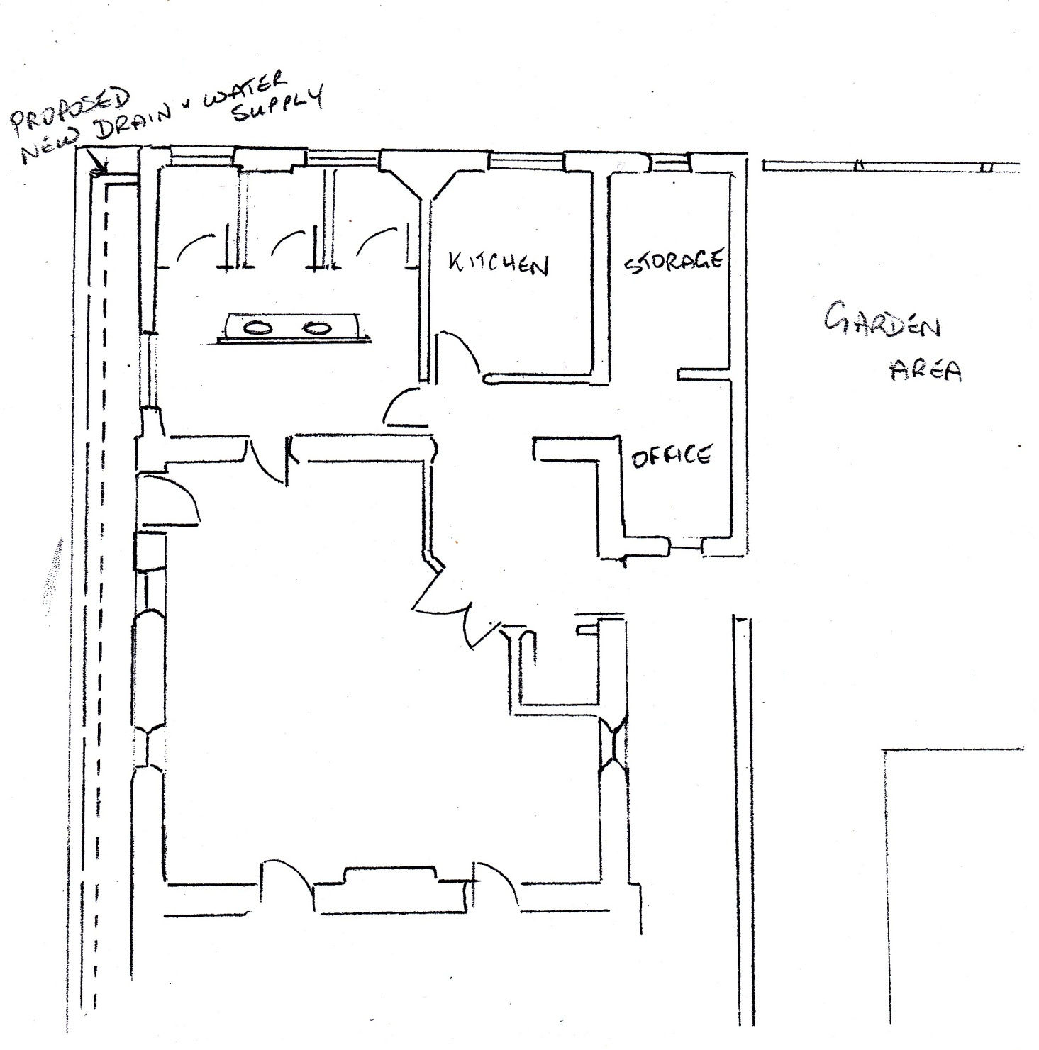

**Pauline’s suggested layout of rear rooms, with disabled access on the left**

**Bradford-on-Avon Churches Together with Bradford-on-Avon Friends of Palestine**

**present a concert:**

**SOMETHING for the SOUL ,**

**featuring GARTH HEWITT.**

**Thurs, 12th Feb 2015, 7.30 pm**

**Holy Trinity Church , Bradford-on-Avon.**

Garth has a special commitment to the Middle East. Singing songs and telling stories from around the world, he presents a moving, challenging spirituality that is warm and inspiring.

**Tickets  on sale from Ex Libris, Bradford-on-Avon from 12.1.15.**

**For information  phone 07505260666**

**Rotas for Church**

|  |  |  |  |  |
| --- | --- | --- | --- | --- |
| Jan | Vestry (V)/ Opening(O) | Books/Welcome | Coffee | Flowers |
| 4 | Brenda Open  Karen Vestry | Dennis and Pat Mills | Brenda and Ron | Hilda Hanks |
| 11 | Joan S. Open  Pauline Vestry | Margaret Edwards and Joan Stephens | Pam &Derrick Copeland | Mary Treadwell |
| 18 | Karen O & V | Penelope and Jack Harrison | Diana and Wendy | Jean Colgrave |
| 25 | Marion O/V | John and Stella Case | Mary and Barry | Betty Fielding |
| Feb |  |  |  |  |
| 1 | Joan J. Open  Tba Vestry | Karen Woollard and Mike Evans | Joan and Evan Jones | Helen Dawson |
| 8 | Brenda O  Barry V | Hilary Reynolds and Nelda Spooner | Brenda and Ron | Sandra Matthews |
| 15 | Helen O/V | Kevin Dawson and Andy Simmons | Debbie and Dennis Major | Pauline Howell |
| 22 | Hilary O  Pauline V | Jenny Sanderson and Joan Agnew | Pam & Derrick Copeland | Susan Hewitt |
| Mar |  |  |  |  |
| 1 | Diane O  Karen V | Karen Woollard and Mike Evans | Mary and Barry | Margaret McDonald |
| 8 | Karen O/V | Debbie and Dennis Major | Diana and Wendy | Marion Hornby |
| 15 | Marion O/V | John and Stella Case | Joan Stephens MarionBarton | Pat Mills |
| 22 | Joan J. O  Karen V | Jenny Sanderson & Margaret Edwards | Joan and Evan Jones | Pam Copeland |
| 29 | Barry O/V | Dennis and Pat Mills | Yvonne and David Syrett | Wendy |

**BOOKS/WELCOME**

**If you are welcoming people and giving them their books and notices please remember to**

1. **Speak to the organist to find out which hymn books will be used in the service and put a copy of the notices in each book ready to hand to people arriving**
2. **If someone is clearly new or a visitor, ask their name and show them to a seat next to a member of the church and introduce them to one another.**
3. **Keep the prayer book available for anyone with a concern (pens are in the little wooden box on the pillar next to the book trolley)**
4. **Turn on the foyer speaker so that you can hear when the service is starting and listen to the prayers and notices at the start of the service.**
5. **Stay in the foyer during the first hymn so that you can give a hymn book and welcome to late arrivals.**
6. **Anticipate that, during the prayer and silence at the beginning of worship some late arrivals might like to wait quietly in the foyer so they do not disturb the opening prayer time, others will feel confident to slip in quietly.**
7. **At the end of the service, help pack away the hymn books used.**

**Thank you to you all for this act of welcome to our church**

Karen

**CHARITY COFFEE MORNINGS 10a.m. to noon. Thank You for your support**

|  |  |  |
| --- | --- | --- |
| **January 11th  2014** | **MEDAIR** | **£96** |
| **February 8th** | **Foodbank** | **£150** |
| **March 8th** | **People Against Poverty** | **£200** |
| **April 12th** | **Alzheimer’s Society** | **£165** |
| **May 10th** | **Christian Aid** | **£111** |
| **June 14th** | **Freedom charity** | **£131** |
| **July 12th** | **Brain tumour research** | **£655** |
| **August 9th** | **Action for children** | **£131** |
| **SEPTEMBER 13TH** | **RWANDA EDUCATION PROJECT** | **£184** |
| **OCTOBER 11TH** | **ZVSF** | **£117** |
| **NOVEMBER 8TH** | **SHOEBOXES** | **£183** |
| **December 13th** | **Wessex Heartbeat** |  |

*If you would like to nominate a charity for May, October or Dec 2015 speak to Joan Jones*

|  |  |  |
| --- | --- | --- |
| **January 10th 2015** | **Medicins Sans Frontieres** |  |
| **February 7th** | **People Against Poverty** |  |
| **March 7th** | **Foodbank** |  |
| **April 11th** | **MEDAIR** |  |
| **May 9th** |  |  |
| **June 13th** | **The Hope Centre** |  |
| **July 11th** | **Zimbabwe Victims Support Fund** |  |
| **August 8th** | **Action for Children** |  |
| **September 12th** | **Rwanda Education** |  |
| **October 10th** |  |  |
| **November 7th** | **Shoeboxes** |  |
| **December 12th** |  |  |

**C:\Users\Joan and Evan\AppData\Local\Microsoft\Windows\Temporary Internet Files\Content.IE5\BMFHRC9K\MC900239951[1].wmf**

**Wedding at our church**

**Helen Mills and Spencer Richards will be getting married at our church on Saturday 24th January 2015, which incidentally is the wedding anniversary of Helen and Kevin Dawson who got married in our church on 24th January 2004 (was this the last wedding at our church, I am not sure?)\***

**The United Church had been a special place for me since moving here in November 2011. The building itself and the warm welcome my grandmother and I received reminded us of the Methodist church we attended in Leigh-on-Sea , Essex where my Grandmother and I were helpers in ten Girls’ and Boys’ Brigade.**

**We are delighted to be getting married at the church and that we have so many of our friends and family coming to share this day with us. I am originally from Essex and lived ( and still work) in London since 1997, so have many guests travelling many miles , including from Austria and Ireland.**

**Spencer is from Trowbridge so his large family does not have to come too far, although he has many friends from Cornwall who will be making the journey, not least his best man who lives in St Just.**

**My daughter, Hannah, along with my 5 God children and niece will be bridesmaids, flower girl and page boy. It has been a busy but enjoyable time so far arranging all that needs to be considered for a wedding.**

**With 150 people coming to the wedding the church will certainly be full, but we would still like to extend a warm welcome to those from the church who would like to come to the ceremony, which will be at 2 p.m. led by Rev David Coppard, with Heather Morgan kindly playing the organ for us.**

**Kind Regards**

***Helen Mills and Spencer Richards.***

(*There have been other weddings but Helen and Kevin Dawson’s was the last wedding of church members. Ed.)

C:\Users\Joan and Evan\AppData\Local\Microsoft\Windows\Temporary Internet Files\Content.IE5\Q8SXY1CW\MC900357149[1].wmf

**As most of you know , I have visited the Way of Joy project in Romania, with People against Poverty, 3 times. This project does amazing work with children and families living in extreme poverty. The Project was started and is run by Valentine Chirica . His wife, son and daughter are now all involved in the work . When I visited the project I shared a pleasant meal in their home on each occasion. His wife, Petronella, runs the medical centre giving free health care to these families. She has been diagnosed with a disease which is causing the bone in her jaw to break down; as a result she needs major surgery. This will be a slow and painful process taking at least 6 months and involving using bone from her hip to rebuild her jaw. As the main wage earner in their household ( as well as her work for the project she is a hospital nurse) this is going to place enormous strain on the family at what is already going to be a difficult and worrying time. The cost of the surgery alone is going to be 8,000 Euros (£6,257) and no state help. Please remember her in your prayers and if, like me, you feel you would like to contribute something to help pay for her treatment please let me know – or contact People against Poverty in Trowbridge.**

Joan Jones

**The Foodbank in Warminster has had a very successful harvest collection. We received 2823kgs of food, much has come from schools and local churches.**

**Our volunteers have been like squirrels, tucking away our goodies ready for Christmas and the months ahead.**

**So far this year we have supported over 2,800 folk, most clients being greeted at our centre in North Row, we are pleased to help all who come.**

**The Christmas season often highlights problems in families, and the Foodbank hopes to repeat last year’s distribution of goodies to families with children.**

**We shall be pleased to receive any items of Christmas foods such as chocolate selection boxes, tins of meat( i.e. ham, corned  beef), mince pies etc**

**Many thanks for the support we receive from this Church.**

**Jean Colgrave**

**21ST CENTURY CHRISTMAS**

**Two thousand years ago, there was no room at the inn,**

**Now there’s no room at Tesco, they’re queuing to get in,**

**That Holy Child had nothing, except a cattle stall,**

**Today’s new generation seems to want it all**

**It must be big, and better than their friend’s in the next street,**

**Yet overseas are children without enough to eat.**

**Christmas shoebox packing is in the right direction.**

**But there are many, many folk who don’t make the connection**

**Between the Christmas carols, that are playing everywhere**

**And the message of the season that we’re privileged to share.**

**Political correctness tries to stop us saying**

**This is the CHRISTmas season, but we must keep on praying**

**That sometime in the future, everyone will know**

**The meaning of that Christmas two thousand years ago**

***Pat Clarke***