AUTUMN 2011
Minister: Revd Norman Price
Tel: 01373 858805
www.unitedchurchwarminster.org.uk
WARMINSTER UNITED CHURCH
(Methodist/ URC)

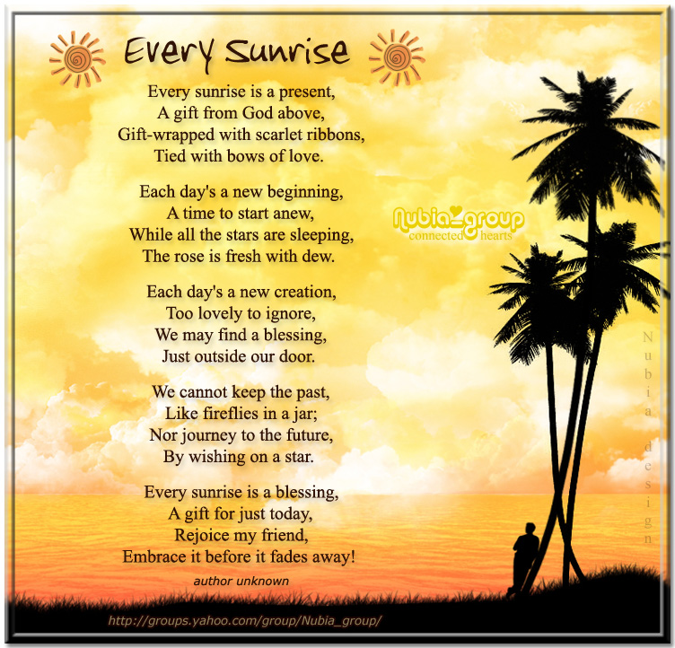

Revd Norman Price will be retiring and leaving our church this time next year. During that year he will be taking a three month sabbatical during September, February and March. In October his wife, Catherine, will be having surgery and Norman will be taking compassionate leave to help her. Next June he will be taking his holiday entitlement to allow them to pack up and look for a new home near their daughter, Leanne. We will miss having them with us and pray for them throughout the year of change ahead.
HARVEST FESTIVAL CELEBRATIONS
Sunday 2nd October
10.30 a.m.: Service led by Jacky and John Williams
To include a short musical entitled
“NAUTICAL NOAH”
written by Heather Morgan
& performed by our choir.
Harvest Gifts of non perishable foods (tins & packets) will be given to Warminster Foodbank,
Gifts of money to the East Africa Crisis Appeal.
Flowers will also be welcome to decorate the church

After the service there will be a
BRING AND SHARE LUNCH

There is a flip chart in church to fill in if you can bring a savoury or sweet dish for lunch, also to show if you are able to help with setting our chairs and tables or washing up afterwards.

All are welcome to this happy sharing event.
Hiring our Premises
This responsible job has been done for years by David Dodge. We were able to thank him for his faithful service at the Church Meeting on 21 August but he is stepping down now and we need a new Hiring Secretary. The job involves putting your phone number on the website so that organisations that want to use our premises can phone and discuss the arrangements and costs. Is this a job you could do?
The costs of hiring our premises have increased this year, after no changes since 2008. The members agreed that, with the changes in fuel prices, we will review the charges annually though we are still one of the cheapest venues in Warminster!
Thanks to Barbara Scott for many years of service as a cleaner for our church, some of that time done for no financial reward. If anyone would like to contribute to a small gift, please see Ruth Dodge.
At the recent Church Meeting it was good to welcome Wendy Womersley as a Pastoral Visitor.

Congratulations Karen Woollard who is now authorised as a Lay Administrator of the Sacrament of Holy Communion.

CHURCH FAMILY NEWS
WELCOME to Regina Danso and her daughter, Rachel, from Firbank Crescent and Edith Quake from Pepper Place.
CONGRATULATIONS AND BEST WISHES to Harriet and Joseph Enos, on the recent birth of Jordan, - a brother for Gladys, also to Yvonne & David Syrett on the birth of their first granddaughter Faith, born to Michelle and Mike on 22nd August

YOUR PRAYERS ARE ASKED for Denis Mills, David Syrett, and John Hewitt who are having tests and treatment in hospital and for Howard Spurr, who is awaiting tests before his hip operation, Len Kibby, and Peggy Griffiths in Henford House, and Gladys Turner at home, also for Coby Blake who we were pleased to see with us again recently but still has health problems.
It is good to see June Laird active again after a nasty fall.
Our Sympathy and prayers go to Sue and Laurie Humphries and family, as Sue's mother, Rachel Keen, died recently, after a long illness. It is good to see Sue & Laurie worshiping with us again and to welcome Sue into the choir.
Happy 1st Birthday to Brianna Opoku-Ware
SUNDAY WORSHIP RESPONSIBILITIES ROTAS
1. Welcome visitors, Greetings, Hymn Books | Rota will be organised by Ruth Dodge
2. Opening Church and setting up the church for Worship (lights, mikes, hymn board etc) | Rota will be organised by Marion Barton
3. Greet and look after the preacher | Rota will be organised by Margaret Edwards
4. Notices and Prayer for Today before the Service | Rota will be organised by Karen Woollard
5. Communion Stewards (preparing communion and arranging to distribute the elements) | Rota: ORGANISER NEEDED
6. Minister’s Support | Team will be led by John Alpin
7.Cover for L.A. and emergency worship | Worship Team led by Karen Woollard
8. Care for the Fijians | Rota will be led by Pauline Howell
9. Social and Outreach | Team will be led by Helen Dawson
At the Church Meeting on 21 August the members agreed to try this new system for leading our church. The rota leaders will collect team members to join in the different activities and then sort out the dates when people can fulfil team duties ready to start in November.
Some Sundays people may find they have two jobs to do, but other Sundays no job at all. It’s a new approach and we will review it at the February Church Meeting, any problems should be shared honestly so we can face them and sort them out.

FUTURE CHURCH AND COUNCIL MEETINGS DATES:
20 November 2011 AGM
Please bring your reports to celebrate the year gone by.
In 2012
9 Feb, 3 May, 9 Aug, 8 Nov (Church Council)
19 Feb, 13 May, 19 Aug and 18 Nov (Church Meetings)

Saturday 24th September at Holt URC
Concert by Pontypridd Male Choir
Contact Myra Green for details 01225 863628

COFFEE MORNINGS IN SEPTEMBER

September 10th for ‘The Mother & Baby Trust’
A charity based in Bristol to raise money for projects and research related to the problems of mothers and/or unborn babies. Hilda Hanks and her family became involved with this charity when her daughter was expecting twins about ten years ago. The babies had ‘Twin to twin transfusion syndrome’ and very few babies with this condition survive or go full-term.
Money is needed for ongoing research into this and other in utero conditions.
Please support the coffee morning in anyway you feel able.
September 17th: Amnesty International are holding a Coffee Morning at our church We are sure members will want to support this coffee morning with their usual enthusiasm.

OTHER COFFEE MORNINGS THIS YEAR:
In June £150 raised for Wylye Valley Disabled riding Centre
In July £160 for Action for Children
In August £200 for Zimbabwe Victims Support

October 8th: Coffee morning for Shoe box appeal
November 12th: for Wessex Heartbeat
December 10th for Education for Rwanda

CHRISTMAS SHOE BOXES
Once again we are hoping to fill as many shoe boxes as possible for Trussell Trust to take out to Bulgaria.
I feel very privileged to help with the organising this year, helped along by our experts, David and Ruth.
Firstly we need to collect shoe boxes and cover them with pretty Christmas paper (cover the lid separately please). If you can get into Stead and Simpson before they close, that'd be wonderful - the Factory Shop have shoe boxes too.
Then there is a CHOICE
You can make up your own shoe box (there are Trussell Trust guidance leaflets here in church to help you know what can go in)
OR
You can contribute to making shoe boxes up together
(OR BOTH).
For the boxes we'll be making together we'll be collecting different items each week through Sep and Oct. Suggestions will be put each week on this notice sheet. You can keep the items at home or bring them to church (we'll need offers from those who'll be able to store items for a week or two please).
Sat October 8th there is a coffee morning to raise some money towards the freight costs
Wed 12th Oct 7.30p.m. Richard Parsons from Trussell Trust is coming here to share a very interesting presentation about the Shoe Box Appeal. Everyone is welcome to this meeting - from other churches too and our families and neighbours.
Finally there will be a "PACKING BOXES DAY" together in mid November before they are blessed in church and made ready for their long journey to their recipients. --> Please start knitting gloves, mitts and scarves (we have a good number of hats already - 120!! - but none will be turned away), also - could you make a shoe bag or two with a pull cords or pencil cases?
Welcome to
Café Morning in Codford

Tuesdays
9am - 12 noon from 6th Sept
at
Greenlight
Welcome to
Café Morning in Codford

Tuesdays
9am - 12 noon from 6th Sept
at
Greenlight
Welcome to
Café Morning
Tuesdays
9am - 12 noon
at Greenlight
If you'd like a little bus journey to Codford on Tuesday mornings, from Tues 13th Sept we'll be making trinket boxes for jewellery for the girls - and other items - at "Cafe Morning" 9am - 12 noon.
Cafe Morning is opening 6th Sept (free cake that day - yummie!). at “Greenlight”, Cherry Orchard, behind school & ‘Codford Caterpillars’ We hope and pray it will serve the community as a meeting point as well as raise some funds for various Christian works in Bulgaria. Please see www.bulgariashare.moonfruit.com
Thank you for your fellowship and generosity in all this. Bob and Chrissie Taylor - Tel: 850 811


The Ladies Choir invites you to an
EVE OF ADVENT CONCERT AND SUPPER
Saturday 26th November from 5.30 to 7.30p.m
The evening will begin with
‘A-BUSTLE IN BETHLEHEM’,
a Musical for Christmas.

This will be followed by an ADVENT SUPPER.
The evening will conclude with organ music and items by the Choir.

There will be a plate for donations to Warminster and District Food Bank and we hope that everyone will be generous in their giving (suggested donation £5 +)
THE CHOIR GOES ‘ON TOUR’!!
On 30th October, Heather and the Choir are leading the morning service at Westbury Methodist Church by singing the Musical recently heard at our Church
‘Forgive and Forget”
The story of the Forgiving Father/Prodigal son

VOICE MAIL
We have learnt to live with ‘voice mail’ as a necessary part of modern life, but have you wondered what would happen if God decided to install voice mail? Imagine praying and hearing this:
“Thank you for calling My Father’s house. Please select one of the following options:
Press 1 for Requests Press 2 for Thanksgiving
Press 3 for Complaints Press 4 for All Other Inquiries”
WHAT IF GOD USED THE FAMILIAR EXCUSE: “I’m sorry, all our angels are busy helping other saints right now; however your prayer is important to us and will be answered as soon as one of our angels becomes available, so please stay on the line”
YOU MIGHT ALSO HEAR:
If you would like to speak to:
Gabriel, Press 1 Michael, Press 2
For a directory of other angels, Press 3
If you would like to hear King David sing a psalm while you are holding, Press 4
To find out if a loved one has been assigned to Heaven, Press 5, enter his or her social security number then press the hash key.
For reservations at ‘My Father’s House’ please enter J-O-H-N followed by 3-1-6.
For answers to nagging questions about dinosaurs, the age of the earth and where Noah’s Ark is please wait until you arrive here.

ALTERNATIVELY YOU MIGHT SEE:
‘Our computers show that you have already prayed once today. Please hang up and try again tomorrow so that others may have a change to get through.
or
‘This office is closed for the weekend to observe a religious holiday, please pray again Monday after 9.30a.m. If you need emergency assistance when this office is closed, contact your local pastor’

Thank God (today) that He doesn’t have voice mail, and that He listens whenever we pray and that will never change!

Submitted by Sandra Matthews

World Church Conference is taking place at Ammerdown Centre on 28-30 October this year. Karen Woollard is going to the Saturday event which will be a series of talks, this year, focusing on the work of Amity Foundation, an independent Chinese voluntary organisation. It's £5 for the day (without meals) and Karen has three spaces in her car.

SERVICES SEPTEMBER TO NOVEMBER
10.30 a.m unless otherwise stated
September 4th: David Morgan
11th: Chrissie Taylor
18th : Rev. Mary Teed
HOLY COMMUNION
25th: Eric Clifford
October 2nd: Jackie & John Williams
HARVEST FESTIVAL
9TH: Chrissie Taylor
16th: Rev. Heather Morgan
HOLY COMMUNION
23RD: Rev. Mary Teed
30th: Isabel Smears
November 6th: Clive Illman
13th: Chrissie Taylor
20th: Eric Clifford
27th: Rev. Mary Teed
HOLY COMMUNION
Evening services at 6 p.m. on 18th September,
16th October & 20th November – see weekly notice sheets for details
Sunday 16th October 10.30 a.m. at Trowbridge United Church
Children’s service led by the
“Clown Vicar” – Rev Roly Bain

4th December will be a joint Advent Service with the Fijian congregation who use our church
LEPROSY MISSION
Copies of the Autumn/Winter catalogue are now available from which you may order cards and gifts. Anyone wishing to order from the catalogue should write down their order and give it to Heather.
THERE IS NO POSTAGE AND PACKING TO PAY if you order through Heather

CELEBRATING KING JAMES BIBLE:
THE BIBLE 'ACCESSIBLE TO ALL' FOR 400 YEARS
Scripture Union's "100 essential Bible Readings" are being read, publically around the Upper Wylye Valley Villages during weeks beginning 10th and 17th October- 10am to 12.30pm weekdays.
Anyone wishing to take part with the reading (15 minute slots) would be really welcome.
Refreshments will be served for those who drop in to listen too.
Please contact Chrissie Taylor on 850811
or email: gigatt@live.co.uk
It would be lovely to have as many folk as possible taking part in this celebration.
Thank you, Chrissie

Next Newsletter due out beginning December -Contributions by November 20th please to joto4biz@aol.com - Joan Jones

